**Data Analysis Project For Hotel Reservation**

**Business Problem:** In recent years, City Hotel and Resort hotel have seen high cancellation rates. Each hotel is now dealing with a number of issues as a result, including fewer revenues and less than ideal hotel room use. Consequently, lowering cancellation rates is both hotels primary goal in order to increase their efficiency in generating revenue, and for us to offer thorough business advice to address this problem.

The analysis of hotel booking cancellations as well as other factors that have no bearing on their business and yearly revenue generation are the main topics of this report.

**Research Questions:**

1. What are the variables that affect hotel reservation cancellation?
2. How can we make the hotel reservation cancellation better?
3. How will hotels be assisted in making the pricing and promotional discounts decisions?

**Hypothesis:**

1. More cancellations occur when prices are higher.
2. When there is longer wait list, customers tend to cancel more frequently.
3. The majority of clients are coming from offline travel agents to make their reservations.

**Analysis and Findings:**

Firstly, we analysed the difference between the cancelled and non cancelled reservation and it was found that 37% for the reservation were cancelled later on which could be seen in the bar graph below.

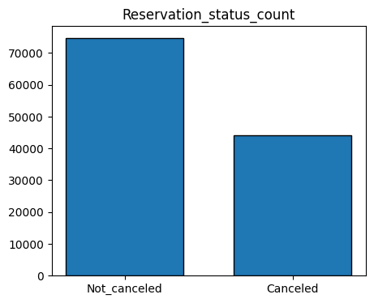

Then had to check the cancellation difference between two different types of hotel. And it was found that more cancellation was seen on the city hotel compared to the resort hotel with approximately 28% cancellation for resort hotel and 42% cancellation for city hotel.

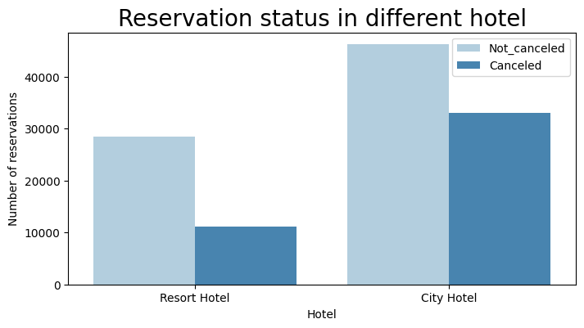

Then average daily rate(adr) was checked for both the hotels which might explain about the more reservation and cancellation in city hotel compared to the resort hotel. And after plotting the line graph for mean adr against the reservation status date, it was proved that the adr for resort hotel is than city hotel. This explains that high profile people only reserved for resort hotel and thus, less reservation and less cancellation.

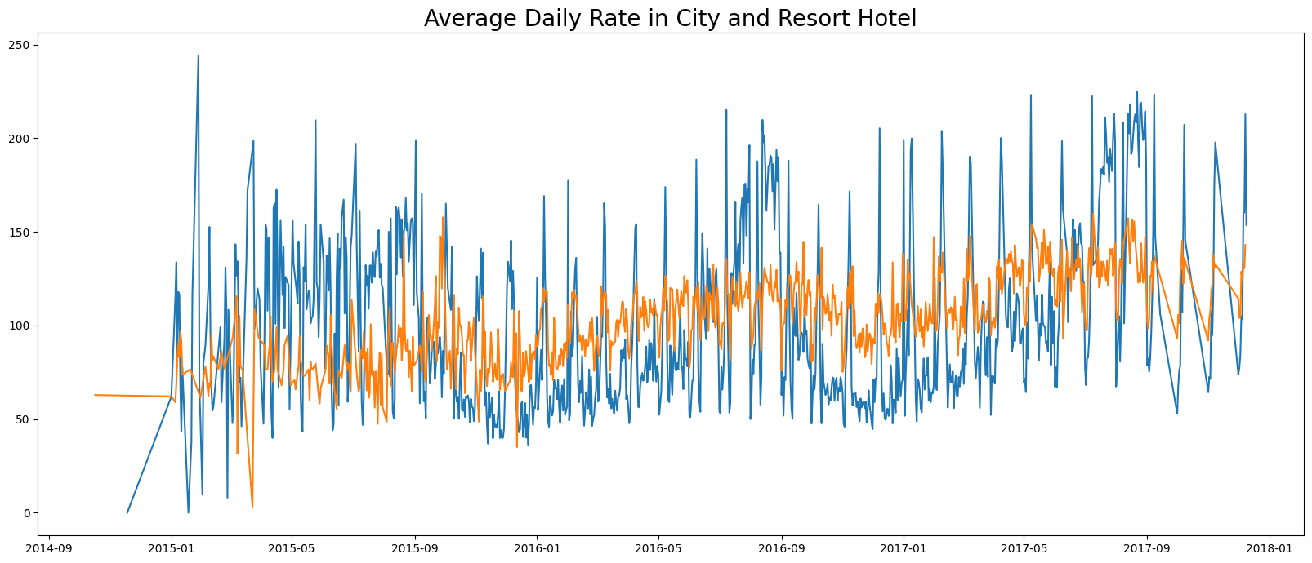

Then analysis to check which month has the highest reservation and which month has the highest cancellation. And the result shows that the month of August has the highest reservation and January has the highest cancellation rates.

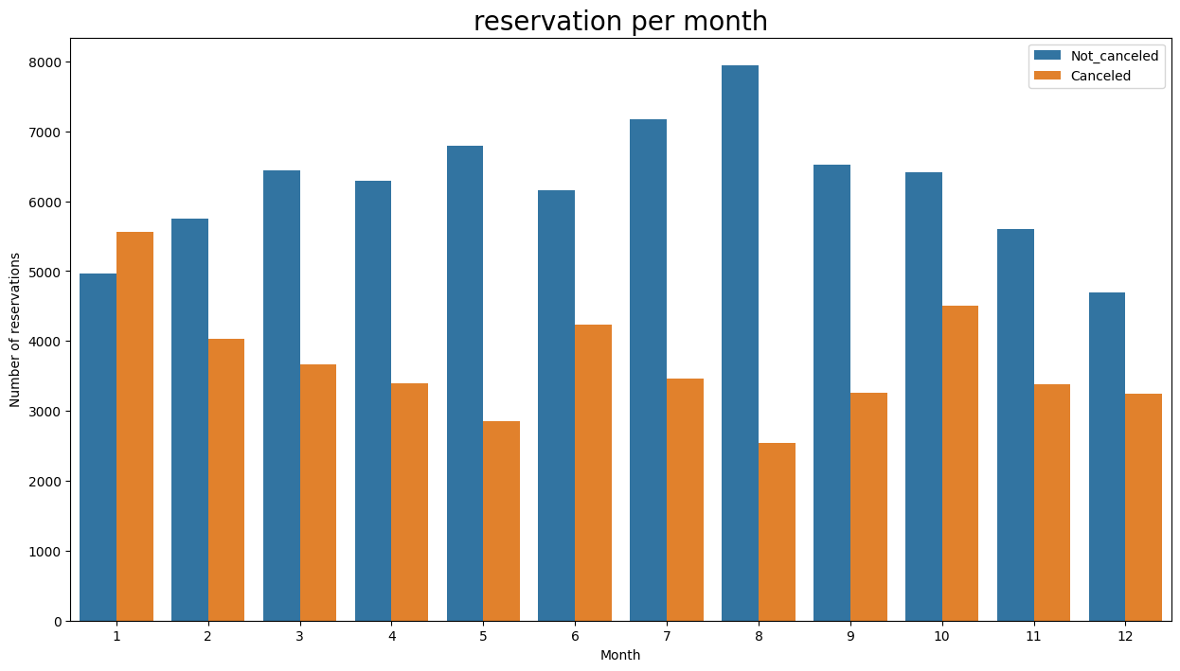

And plotting the ADR for each month explains the above calculation.

The plot explains that the adr is highe for January and low for August which resulted in more reservation in August and high cancellation in January.

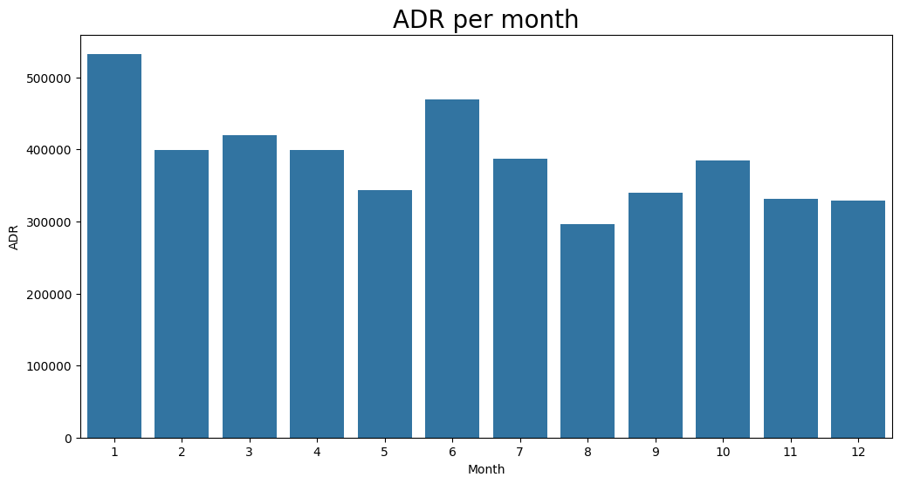

Then analysis is needed to check which country has the highest cancellation rates. And the result explains that 70% of the cancellation happens at Portugal.

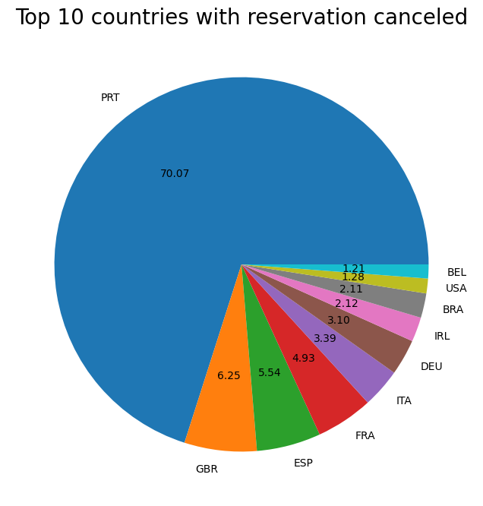

The Analysis was done to check our hypothesis if majority of the clients are making the reservation through offline travel agent. The result contradicts with our hypothesis and it was found that online travel agent was the highest segment for the reservation with 47% where as the offline TA have just 20%. Then we had to check which segment had more cancellation and the result shows the online travel agent also had the highest cancellation rates.

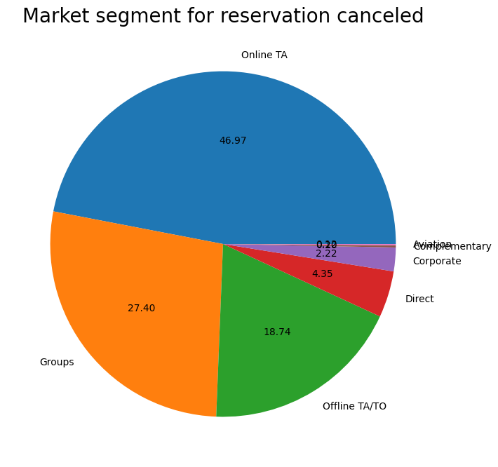

Now, finally analysing for our hypothesis if cancellation is more due to higher adr. Plotting the line graph for reservation staus date and mean adr for both the cancelled and non cancelled data gives us the result of verifying our hypothesis, which means that adr is high for cancelled reservatio and low for non cancelled reservation.

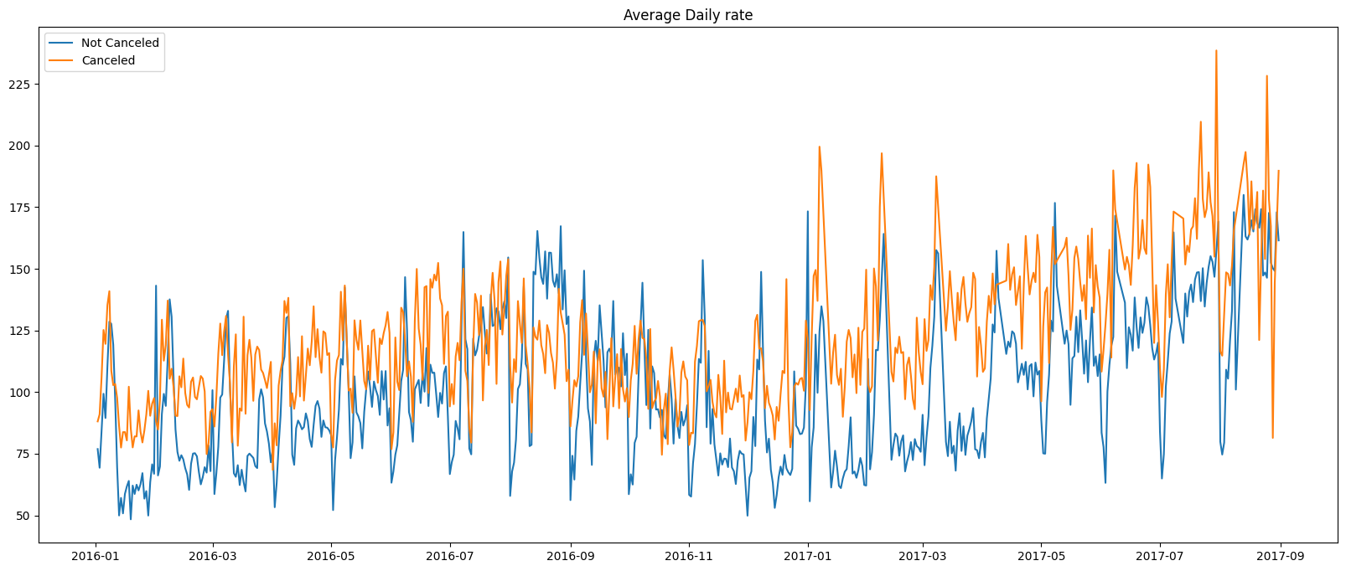

**Suggestions:**

1. Cancellation rates rise as the price does. In order to prevent the cancellations of reservations, hotels could work under pricing strategies and try to lower the rates of specific hotels based on locations. They can also provide some discounts to the consumers.
2. As the ratio of the cancellation and not cancellation of the resort hotel is higher than the city hotels. So, the hotel should provide a reasonable discount on the room prices on weekends or on holidays.
3. In the month of January hotels can start campaigns or marketing with a reasonable amount to increase their revenues as the cancellation is the highest in this month.
4. They can also increase the quality of their hotels and their services mainly in Portugal to reduce the cancellation rate.